 Cross Country Program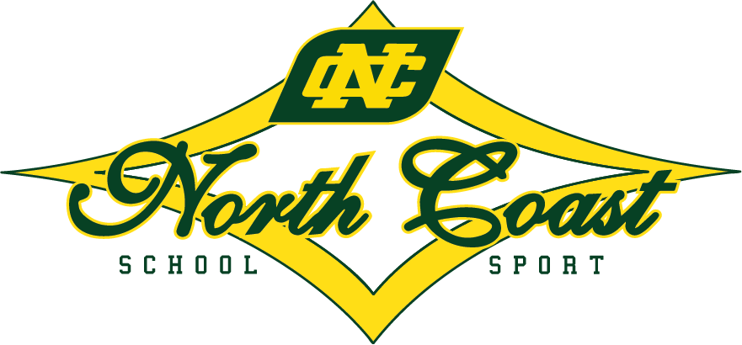
NC PSSA & CHS Cross Country Championships
Wiigulga Sports Complex, Solitary Islands Way, Woolgoolga
Friday 13 June 2025
Time | Details | Distance | Secondary/Primary
9:30am | Teams Arrive | Nil | All
9:45am | Walk the course | Nil | All
10:00am | Team Managers Meeting | Nil | All
10:30 am | 18+ year boys | 8000m | Secondary
 | 10 year boys including Multi Class | 2000m | Primary
 | 18+ year girls | 6000m | Secondary
 | 10 year girls including Multi Class | 2000m | Primary
 | 16 year boys | 6000m | Secondary
 | 16 year girls | 4000m | Secondary
 | 8/9 year boys including Multi Class | 2000m | Primary
 | 8/9 year girls including Multi Class | 2000m | Primary
 | 11, 12 &13 year boys and girls Multi Class | 2000m | Primary
 | 17 year boys | 6000m | Secondary
 | 17 year girls | 4000m | Secondary
 | 11 year boys | 3000m | Primary
 | 11 year girls | 3000m | Primary
 | 12 year boys including all CHS Multi Class | 3000m | Secondary
 | 12 year girls including all CHS Multi Class | 3000m | Secondary
 | 14 year boys | 4000m | Secondary
 | 14 year girls | 4000m | Secondary
 | 12/13 year boys | 3000m | Primary
 | 12/13 year girls | 3000m | Primary
 | 15 year boys | 4000m | Secondary
 | 15 year girls | 4000m | Secondary
 | 13 year boys | 3000m | Secondary
 | 13 year girls | 3000m | Secondary

